

ALPHA TAU OMEGA
VIKING GAMES 2015
Info Packet
TABLE OF CONTENTS

- Overview
- Event Information/ Rules
- Points System
- Team Entry Form

Overview
The 1st annual ATO Viking Games is a philanthropy event that takes place the first week in February. The proceeds from the event will be donated to the winning sorority’s philanthropy! This week long event will put the lovely ladies of the Florida Atlantic University Panhellenic Council to the test in games of teamwork, skill, and participation. The week culminates at Henderson Fields where you will fight to become Alpha Tau Omega’s Viking Games Champion. May the odds be ever in your favor!

ENTRY FEE (Due by February 5th, 2015)

$100 Per Sorority
Cash, Check, or Credit Card
Please make checks out to “Alpha Tau Omega”

EVENT OVERVIEW

TABLING (February 2-6, 2015)
- Monday thru Friday from 10:00AM-3:00PM
- Money Wars
- Each sorority will have a chest designated for donations
- Dollars are worth double their value
- Coins are worth normal value
- T-Shirt Sales
- $15 per shirt
- Cash or Credit Card
SUBWAY FUNDRAISER
- Date TBA
- Subway on campus at FAU
- Sign in sheet for each sorority will be located inside store
- Guests are also welcome and can sign in for a sorority
- If you or your guest makes a purchase place the receipt with your name and sorority in the bucket designated for your sorority. It will be worth double points.
PINNING CEREMONY
- Monday February 2, 2015 in Grand Palm Room
- Alpha Tau Omega’s Only Ritual allowed to be viewed by the public
- 2 Points per sorority member who attends and 50 points to the sorority with the most attendees.
- Come out and meet the newest members of the Alpha Tau Omega Fraternity

The Viking Games
- February 5, 2015 at Track and Field by Arena
- Check in/ Warm up is at 6:30 PM
(all team members must be present at this time)
- Games start at 7:00 PM
- $5 entry fee for any guests not in a participating sorority

- Flag Football
- 12 Players per sorority 10 minute games/ 2 Games at a time
- Top 2 sororities in donation amounts in chest will be given a first round Bye
- Points for 1st 2nd and 3rd
- Each sorority can have up to 5 Subs for flag football
- Same color shirts must be worn by each sorority
- Relay Races
- Ballon Pop Relay, Water jug Relay, Tennis Ball Relay
- 5 contestants per sorority per race
- Races include a variety of fun obstacles
- Points for 1st 2nd and 3rd for each race

- Soccer
- 7 contestants per sorority
- Winners of Flag Football and Relay Race will receive first round bye
- Points for 1st 2nd and 3rd
- Champions Ceremony/ Group Picture
- Winning sorority will be announced
- Trophy will be presented and a group photo with winners

VIKING GAMES RULES
- All sporting events during the first annual Viking games will follow the rules established by Campus Recreation at Florida Atlantic University.

- Each sorority is allowed 5 subs for flag football.

- Team rosters as well as subs need to be submitted by email to Ryan Corbitt by January 31, 2015.

- Outside guests that are not in a participating sorority or fraternity must pay the $5 dollar admission fee at the gate before entering the games.

- T-Shirt sales and pinning ceremony for each sorority will be for bonus points. Each sororities total number of shirts bought will be ranked and then points will be given as follows:
1st= 200 Points 2nd = 100 Points 3rd= 75 Points 4th= 50 points 5th = 25 points 6th= 0 points

POINTS SYSTEM

TABLING
- Every Dollar donated to chest = Every $1 = 2 Points
- Every Dollar in change = Every $1= 1 Point
- Total Shirts Purchased by each Sorority will be ranked 1-6 then given bonus points based on rank.

SUBWAY FUNDRAISER
- Sorority Member Sign In 2 Points per person
- Guests, Fraternities, ect. 1 Point per person

THE VIKING GAMES
- Sorority Attendence 2 Points per person/ 1 point per guest
- Sorority with most attendees 300 Points

- Flag Football 1st= 800 Points 2nd = 500 Points 3rd = 300 Points

- Tug Of War 1st = 500 Points 2nd= 300 Points 3rd = 150 Points

- Relay Races (3 Races) 1st= 200 points 2nd= 100 Points 3rd= 50 Points

PINNING CEREMONY
- 2 Points per sorority member who attends
- Bonus Points for the sorority with the most attendees

IF YOU HAVE ANY QUESTIONS PLEASE CONTACT ME ANYTIME. EMAIL PREFERED!

CONTACT INFO
Ryan Corbitt
Alpha Tau Omega Philanthropy Chair
Rcorbitt2013@fau.edu
(518)312-3624

ATO VIKING GAMES ENTRY FORM

SORORITY:_____________________________________________

TEAM NAME:____________________________________________

Entry Fee:$100 (due by 02/07/2015) Cash, Check, or Credit Card
Please make checks out to “Alpha Tau Omega”

NAME | FLAG FOOTBALL | SOCCER | RELAY RACE
1
2
3
4
5
6
7

T_SHIRTS WILL ALSO BE ON SALE FOR $15 dollars Cash or Credit

$5 Admission for guests

PLEASE EMAIL ME TEAMS BY JANUARY 31, 2015

CONTACT INFO
Ryan Corbitt
Alpha tau Omega Philanthropy Chair
Rcorbitt2013@fau.edu (518)312-3624
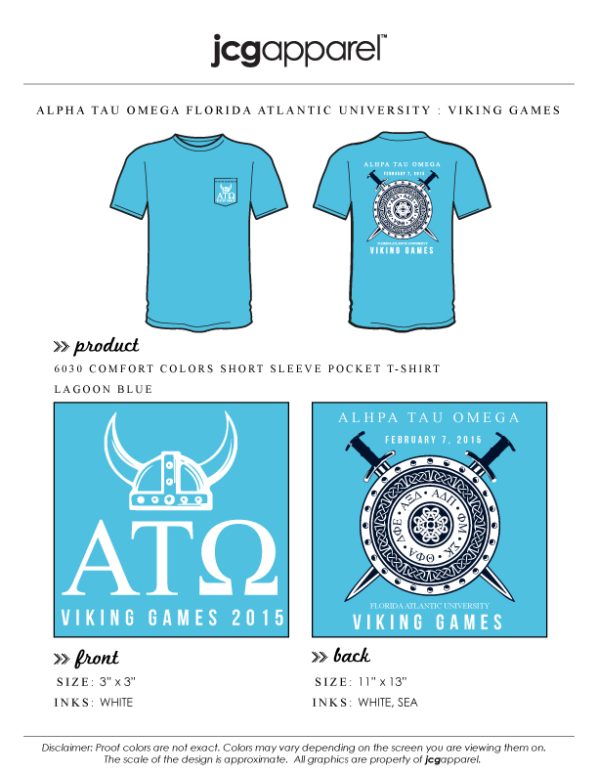

Comfort Colors T-Shirts Available in 3 More Colors

$14.50 Credit Card at our online store

http://www.jcgstore.com/index.php?store=ATO-FAU

